EasyCode: High-Level Design (HLD)

Vision & Roadmap
EasyCode is a scalable Online Judge and DSA Learning Platform built for users ranging from absolute beginners to competitive programmers. It is designed to scale across five distinct phases:
- V1 (Core OJ): Secure code execution, problem checking, and basic profiles.
- V2 (Learning): Structured DSA roadmaps, guided paths, and progress gamification.
- V3 (Community): Contests, Elo-based ratings, peer discussions, and user-made content.
- V4 (AI Mentor): Automated code reviews, personalized dynamic hints, and mock interviews.
- V5 (Enterprise): B2B features for universities and recruiters (anti-plagiarism, auto-grading).

Technical Stack & Architecture

Tech Stack
- Frontend: React, React Router, Monaco Editor, Axios
- Backend: Node.js, Express.js
- Database: MongoDB & Mongoose
- Judge Sandbox: Docker
- Infrastructure: AWS
Design Choice: Separating the Judge Service into an isolated worker system from day one ensures that heavy compilation tasks won't crash the main user API, making future horizontal scaling straightforward.

Core Functional Blocks (V1 - V5)

1. Code Execution Pipeline (The Judge)
When a user submits code, it passes through a secured execution pipeline:
$$\text{Frontend Submission} \rightarrow \text{API Gateway} \rightarrow \text{Judge Queue} \rightarrow \text{Secured Docker Container}$$
- Sandboxed Security: Containers run with strict resource quotas to prevent malicious actions like fork bombs or infinite loops:
  - CPU & Memory Limits: Hard caps on processing power and RAM usage per execution.
  - Network Disabled: Complete isolation to prevent data exfiltration or external requests.
  - Read-Only File System: Prevents code from modifying the host system or writing malicious files.
  - Execution Timeouts: Automatic termination if code runs longer than the allowed time limit.
- Verdicts Issued: * AC (Accepted)
  - WA (Wrong Answer)
  - CE (Compilation Error)
  - RTE (Runtime Error)
  - TLE (Time Limit Exceeded)
  - MLE (Memory Limit Exceeded)

2. Learning Ecosystem & Gamification
- Roadmaps: A linear progression track spanning from basic syntax up to Advanced Dynamic Programming and Graph algorithms.
- Editorials: Multi-tier solutions for problems mapping out Brute Force $\rightarrow$ Better $\rightarrow$ Optimal approaches with space/time complexity bounds.
- Engagement Engine: Daily streaks, XP, level unlocks, and badges to incentivize consistent practice.

3. Competitions & Community
- Contest Engine: Support for custom-timed public/private contests with a live leaderboard and dynamic Elo-like ranking shifts.
- Social Layer: Upvotable discussion forums embedded inside each problem and customizable public developer profiles.

4. AI & Enterprise Adaptations
- AI Hint Engine: Delivers progressive pseudocode hints and code quality analysis without directly spoiling solutions.
- B2B Tools: Virtual classrooms for schools, automated code plagiarism checks, and candidate screening templates for tech recruiters.

Non-Functional Requirements (NFRs)
- Performance: API response times under 300 ms (excluding background evaluation runtimes).
- Security: Cryptographic password hashing (bcrypt), JWT-driven access control, and complete execution isolation.
- Maintainability: Standardized MVC code architecture with centralized logging and automated Docker health checks.

Core API Endpoints (V1)

Authentication Service
- POST /api/auth/register — Register a new account.
- POST /api/auth/login — Authenticate user and return a JWT access token.
- POST /api/auth/logout — Invalidate user session.

Problem Service
- GET /api/problems — Fetch filtered list of problems (Search, Difficulty, Tags).
- GET /api/problems/:id — Retrieve detailed problem description, constraints, and sample test cases.
- POST /api/admin/problems — (Admin Only) Create a new challenge.
- POST /api/admin/problems/:id/testcases — (Admin Only) Upload hidden input/output execution suites.

Execution & Dashboard Service
- POST /api/submissions/run — Fast execution of transient code strings against public sample cases.
- POST /api/submissions/submit — Formally evaluate problem solution against complete hidden test suites.
- GET /api/submissions/history — Fetch execution records for a specific user.
- GET /api/users/profile/:id — Aggregate basic analytics (Easy/Medium/Hard resolution counts).

ER Diagram for V1:
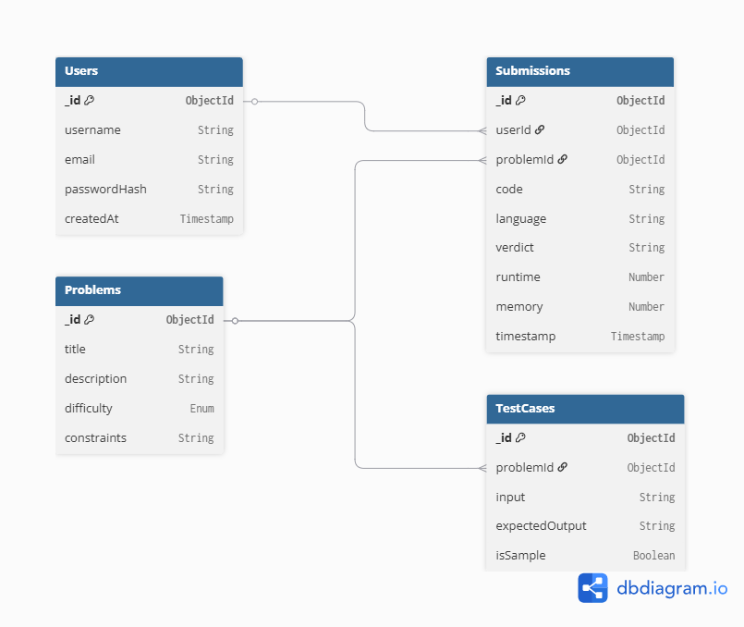

High Level Architecture diagram for V1:
